Smarter Diabetes Management

Key Leadership

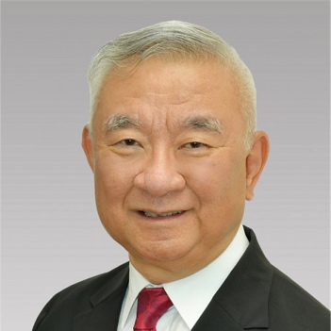 | Sidney Chan, Chairman, Chief Executive Officer  Mr. Chan oversees the strategic planning of the company to achieve its mission to deliver innovative technology-based solutions to improve health outcomes while reducing health care costs.  Mr. Chan has been involved in managing and developing ALR Technologies since August 1997 and was instrumental in taking the company public. Prior to ALRT, Mr. Chan had an extensive background in structured finance as President and CEO of the Knight's Group of Companies. Prior to the founding of the Knight's Group of Companies Mr. Chan worked for the predecessor companies of RBC Dominion Securities as well as Cominco, the mining subsidiary of Canadian Pacific.
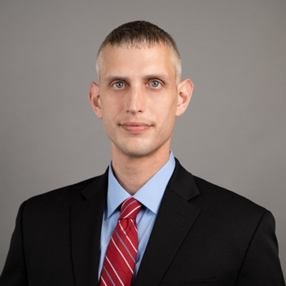 | Joe Stern, Head of Animal Health  Mr. Stern possesses over 20 years of experience in various industries, specializing in project management and operations, with 15 years spent at a Fortune 50 company. Mr. Stern has led a number of large-scale B2B projects worth hundreds of millions of dollars and helped lead his region's revenue from its infancy to over half a billion dollars annually. His focus was to oversee projects in construction, government contracts, business partnerships, product launches, product development, information systems design and deployment (billing, platforms, apps), fleet purchasing and maintenance, as well as training of 1,000+ employees on various technologies.
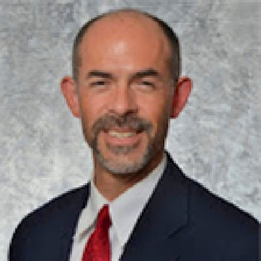 | Dr. Kent Stoneking, Director, Clinical Program Development  Dr. Stoneking, Pharm.D., CDE, gives direction to the clinical development process, ensuring that patients’ blood glucose records are represented accurately in the ALRT database for providers’ review and intervention. He also maintains the therapy advancement algorithm to give providers clinical decision support.  Dr. Stoneking is a pharmacist and Certified Diabetes Educator (CDE) who has extensive, hands-on experience working with a network of primary care and endocrinology providers to assist patients with medications, diabetes education and self-management training. He has practiced in community, academic, and corporate pharmacy settings. He currently serves as Director of Pharmacy and Wellness at Pinnacle Medical Solutions, LLC.

Get in touch with us at media@ALRT.com

